**Use Case for My Request Timeline comment.**

**Actors: Requestor**

**Description:**

* To provide users with a detailed timeline view of their requests, displaying key events and allowing users to comment and track the progress. The top panel shows the approval status, delivery status, and a comment box for users to add comments or view existing ones.

**Trigger Point:**

* The trigger point for this use case is when a user accesses the "My Request Timeline" section to track the progress of their submitted requests.

**Precondition:**

* The user must have valid login credentials and appropriate access rights to access the request timeline.

**Normal Flow:**

**1 Login:**

* The user logs in to the system using valid credentials.

**2** **Access My Request Timeline:**

* The user navigates to the "My Request Timeline" section.

**3 Top Panel Overview:**

* The top panel displays the following items:
* Approved/Not Delivered status.
* Comment box for users to add comments or view existing ones.

**4 Commenting:**

* The user can add comments or view existing comments in the comment box.

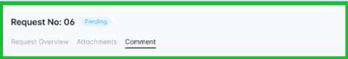

**5 Request Timeline:**

* The request timeline provides a chronological overview of the request's progress:
* Initiated the Request: Created time 04/07/2023:08:00:00 am.
* Initiated Request Approved: Approved time 04/07/2023:08:00:00 am.
* Send for RFQ: Created time 04/07/2023:08:00:00 am.
* Seek Quotes: Purchase Order Confirm - Created time 04/07/2023:08:00:00 am.
* CAB Review: Waiting for Delivery - Created time 04/07/2023:08:00:00 am.
* Implement Request Closed - Created time 04/07/2023:08:00:00 am.

Validate.

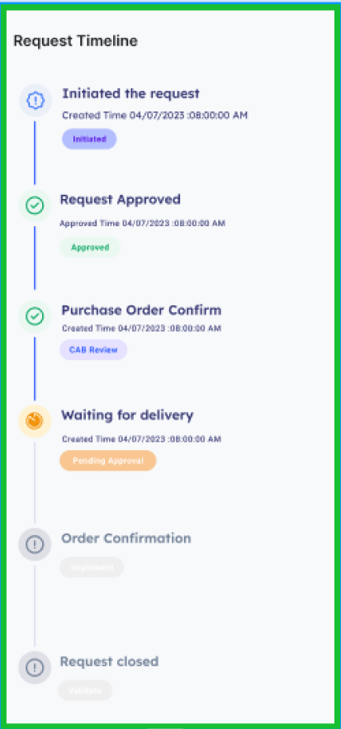

**6 Order Line Details:**

* The request timeline includes details for each item in the request:
* Line Number (automatically assigned).
* Item Name.
* Quantity.
* Unit.
* Price.
* Total Cost.
* Post Condition:

The user has a comprehensive view of the request timeline, including approval status, delivery status, and comments. Any new comments are added to the system.

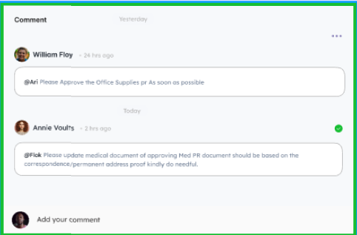

**Alternative Flow:**

**1 Invalid Login:**

* If the user enters incorrect login credentials, the system triggers an authentication error message, prompting the user to enter valid credentials.

**2 Error in Request Timeline**:

* If there's an error in retrieving or displaying the request timeline, the system triggers an error message, and the user is prompted to try again.

**3 No Comments Available:**

* If there are no comments available for the request, the system displays a message indicating no comments.

**4 Error in Commenting:**

* If there's an error in adding a new comment, the system triggers an error message, guiding the user to try again.

**Benefits:**

1. Transparent Progress Tracking: Users can monitor the progress of their requests through a detailed timeline.
2. Interactive Commenting: Users can provide and view comments, facilitating communication throughout the request lifecycle.
3. Quick Overview: The top panel provides a quick summary of the approval and delivery status.

By following this use case, organizations can enhance user experience by providing a detailed and interactive timeline for users to track the progress of their requests.